**TITLE**

The effects of nondimentionalization in Physics-Informed Neural Networks applied to the Kinetics of Biological Reactions: A case study with *Lactobacillus casei*

**AUTHOR LIST**

Renan Mendes Frotaa,Ivanildo José da Silva Juniora,*, Amaro Gomes Barreto Juniorb.

*a Universidade Federal do Ceará, Departamento de Engenharia Química, Campus do Pici, Bloco 709, 60455-760 Fortaleza, CE, Brazil*

*b Chemical and Biochemical Engineering Processes (EPQB), School of Chemistry—EQ/UFRJ, Universidade Federal do Rio de Janeiro (UFRJ), Cidade Universitária, Ilha do Fundão, Rio de Janeiro 21949-900, Brazil*

*\*Corresponding author.*

*Email address: ivanildo@ufc.br*

*Full postal address: Universidade Federal do Ceará, Departamento de Engenharia Química, Campus do Pici, Bloco 709, 60455-760 Fortaleza, CE, Brazil*

1. Figures

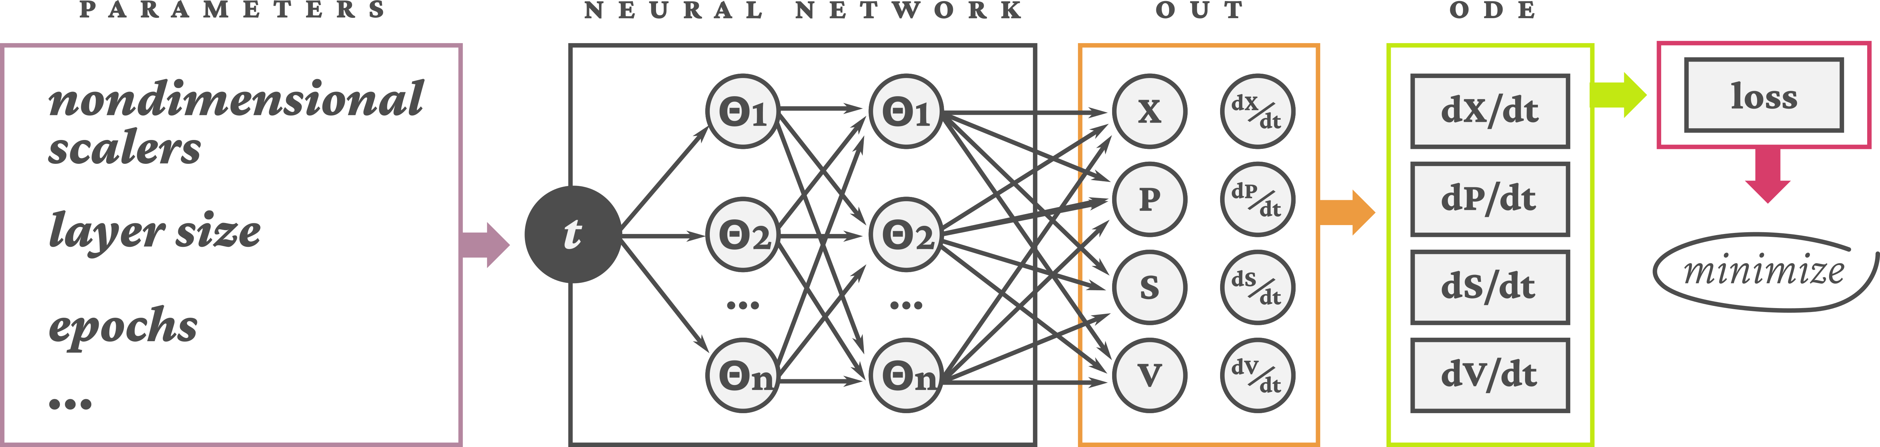Figure 1: Schematic of the PINN model

Figure 2: Nondimensional test, layer test and comparison between experimental data and PINN results

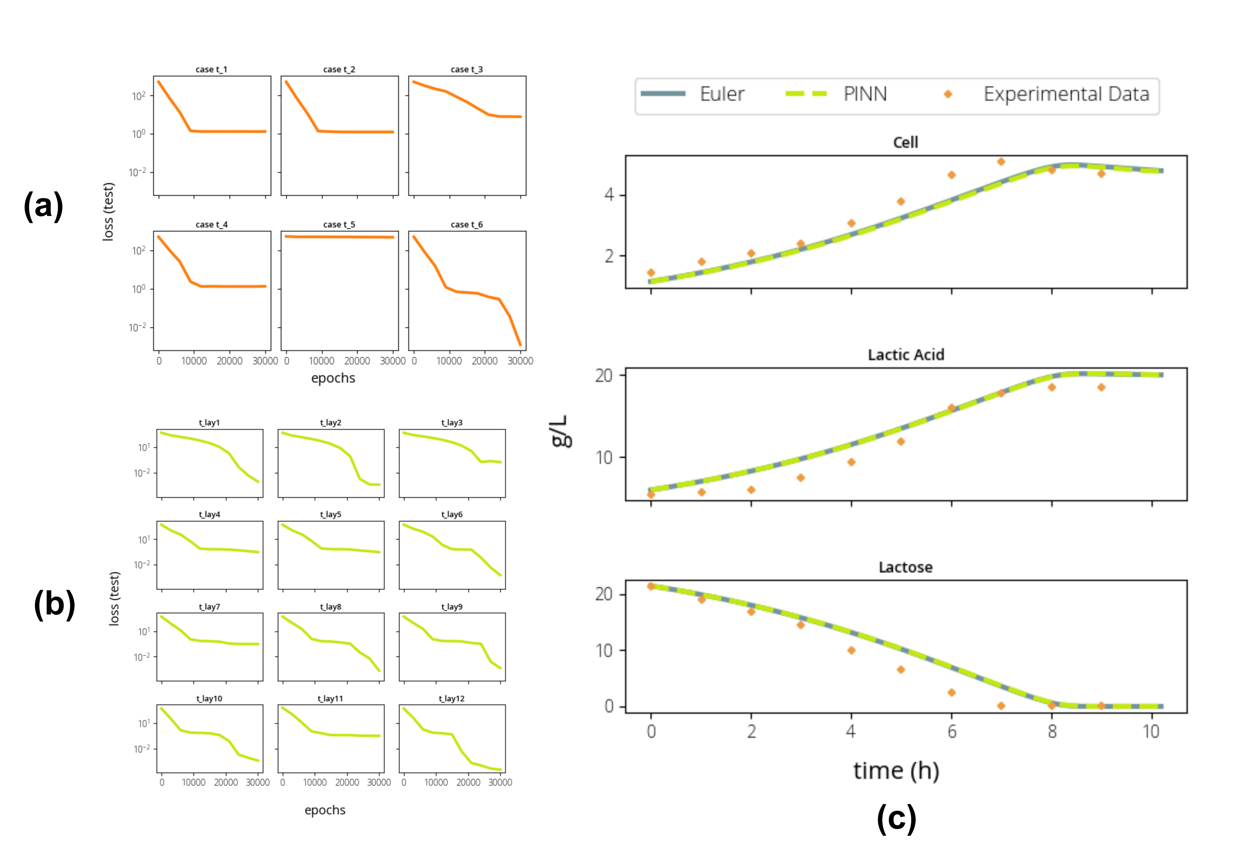

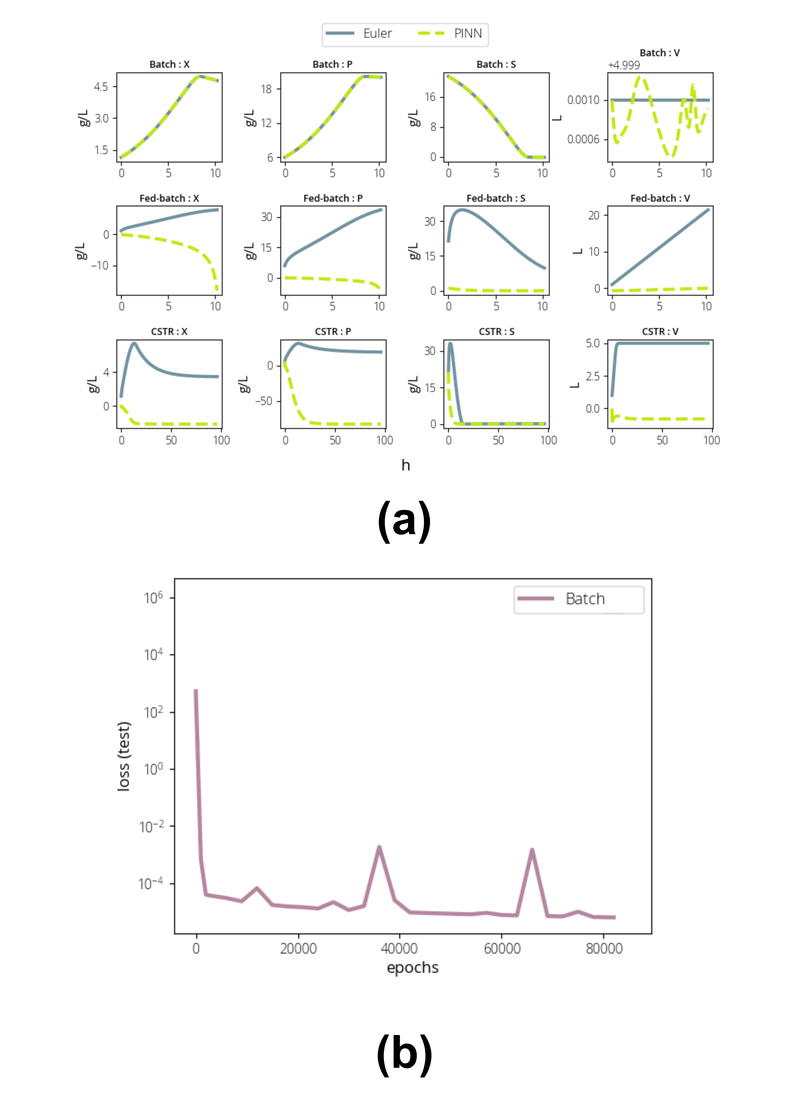Figure 3: PINN results comparison for Bacth, Fed-batch and CSTR reactors

1. Declaration of interest

Declarations of interest: none

1. Highlights
2. Volume and biomass concentration are the more relevant variables for loss minimization
3. The batch reactor was successfully simulated using PINN
4. PINNs were not capable of appropriately simulate reactors with volume variation
5. Strategies for simulating reactors with volume in transient state are suggested